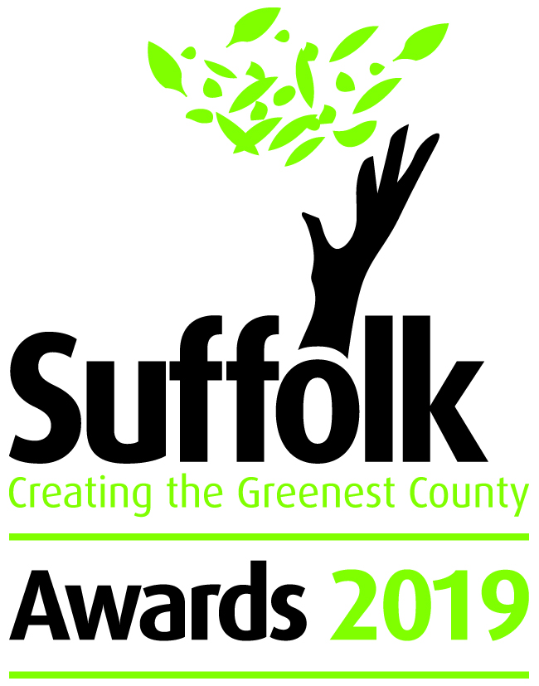

Valuing Water

The Creating the Greenest County awards celebrate the environmental excellence of organisations across Suffolk. The awards are an annual event highlighting how Suffolk's individuals, communities, businesses, schools and third sector organisations are leading the way.

Category information & criteria
This award recognises the work carried out by any individuals, schools, businesses, communities or third-sector organisation that are taking innovative approaches towards saving water resources. It can be in the home, garden, at work, in the fields of by raising awareness. If you are using it wisely we want to hear about it.

This category will be judged against the following:
- Level of ambition of the project (20%)
- Engagement and influence with staff, customers, pupils and/or the local community (20%)
- Evidence of improved water management (50%)
- How do you see your actions developing? (10%)

Closing date for entries – 20 May 2019

Email your completed entry form to creatinggreenestcounty@suffolk.gov.uk

Your details
Contact Name
Job Title
Name of Community, Group, Business or School
Size of group
Address
Telephone Number
Email Address
Website
Twitter ID
50 words to describe you/your group/organisation – This maybe used for publicity

Compulsory questions are marked with a *

Please give a summary of your work (max. 250 words) *
How have your actions helped to improve efficient water use? (max. 500 words) *
How have you involved others? (max. 500 words) *
Briefly describe how you see your actions developing in the future.
(max. 250 words) *
Please give details of any other environmental awards or standards

Award details:
The awards are for 2018-19, so key actions should have taken place in the last 12 months. Information relating to earlier years may be included as background or to describe supplementary actions.

Please do not include any additional supporting information or materials with your completed application form. Any additional information will not be counted during the judging process.

Assessments will be undertaken by independent judges, who will make their decision based on the answers given in the form.

For more detailed information and rules, please visit www.greensuffolk.org/awards

Timeline
14 March 2019 Awards open
20 May 2019 Deadline for entries
May 2019 Judging of awards
17 July 2019 Winners announced at awards ceremony

If you have any queries regarding your application form:

Email: creatinggreenestcounty@suffolk.gov.uk
Telephone: (01502) 521406

Follow us on Twitter for the latest Award information @greensuffolk

