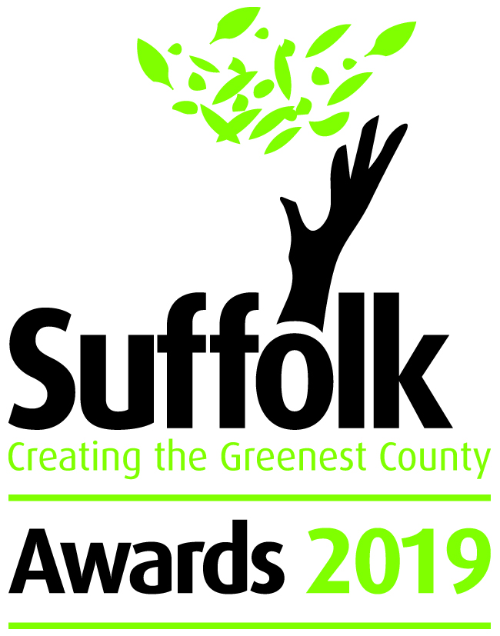

Terms and Conditions
The Creating the Greenest County awards celebrate the environmental excellence of different organisations across Suffolk. The awards are an annual event highlighting how Suffolk's individuals, schools, communities, businesses and third-sector organisations are leading the way.
The Awards aim to:
- Reward excellence in Suffolk.
- Promote connections between organisations within Suffolk.
- Highlight the benefits of good environmental performance.
- Raise public awareness of Creating the Greenest County.
All entrants must:
- Be located within Suffolk or working on a project based in Suffolk. Entries are welcome from local branches of national organisations, but the application must be based on actions undertaken within Suffolk.
- Demonstrate a strong commitment to the environment through action taking place in the last 12 months.
- Winners of previous Greenest County Awards are welcome to apply for any category.
Creating the Greenest County reserves the right to:
- Share any information submitted in the application with third parties, whilst honouring any specific areas of confidentiality. Please state clearly within the application where information provided is confidential.
- Move an entry from one category to another if they feel it is more appropriate.
Judging:
- All entries will be judged by four specialists in that particular field.
- Judging will be undertaken independently and all scores will be kept confidential.
- The judges' decision is final and no correspondence will be entered into.
If you have any questions about the Awards 2019 please email: creatinggreenestcounty@suffolk.gov.uk or telephone (01502) 521406

Timeline for Awards 2019:

14 March 2019 Awards open for entries

25 April 2019 Deadline for entries

May 2019 Judging of awards

17 July 2019 Winners announced at awards ceremony

