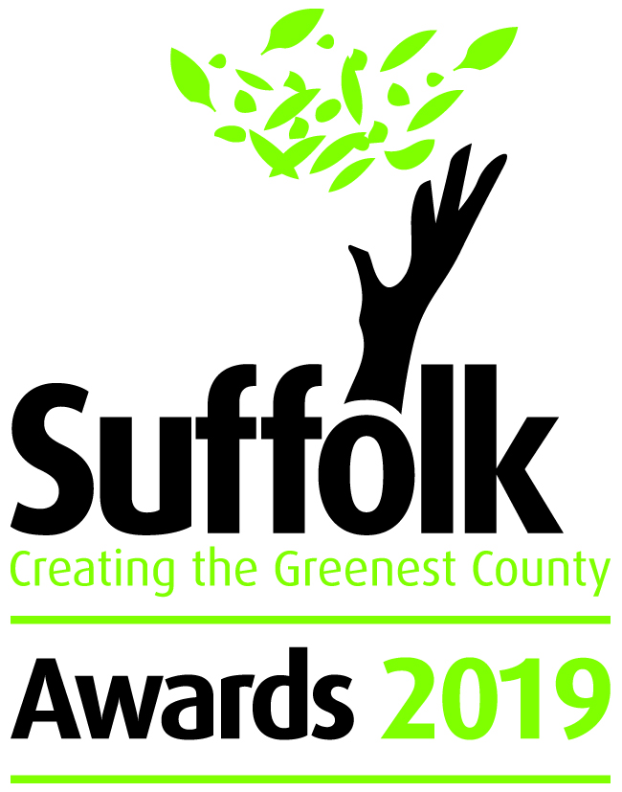

Local Energy
Supported by University of Suffolk

The Creating the Greenest County awards celebrate the environmental excellence of organisations across Suffolk. The awards are an annual event highlighting how Suffolk's individuals, communities, businesses, schools and third sector organisations are leading the way.

Category information & criteria
We’re looking for projects that demonstrate excellence in the field of local energy, from buildings to community-scale schemes to businesses. Has your scheme demonstrated an innovative approach to energy provision, efficiency, funding, or the development of smart grids, or delivered wider benefits to the community? If so, we want to hear from you.

This category will be judged against the following:
- Environmental and social benefits – e.g. energy delivered, expected lifetime carbon savings, reduction in levels of fuel poverty, improvements to benefit biodiversity (30%)
- Wider significance – How innovative is the scheme? Is it widely replicable? (40%)
- Engagement with residents, schools and businesses in the local community (30%)

Closing date for entries – 20 May 2019

Email your completed entry form to creatinggreenestcounty@suffolk.gov.uk

Your details
Contact Name
Job Title
Name of Community, Group, Business or School
Size of group
Address
Telephone Number
Email Address
Website
Twitter ID
50 words to describe you/your group/organisation – This maybe used for publicity
Compulsory questions are marked with a *

Briefly describe the project, including achieved and/ or projected environmental and social benefits (max. 500 words) *
Why does this project deserve an award? Describe the innovative aspects, and what others may be able to learn from you (max. 500 words) *
How was the community involved in the development of the project and what benefits will they derive, including any future plans (max. 500 words) *
Please give details of any other environmental awards or standards

Award details:
The awards are for 2018-19, so key actions should have taken place in the last 12 months. Information relating to earlier years may be included as background or to describe supplementary actions.

Please do not include any additional supporting information or materials with your completed application form. Any additional information will not be counted during the judging process.

Assessments will be undertaken by independent judges, who will make their decision based on the answers given in the form.

For more detailed information and rules, please visit www.greensuffolk.org/awards

Timeline
14 March 2019 Awards open
20 May 2019 Deadline for entries
May 2019 Judging of awards
17 July 2019 Winners announced at awards ceremony

If you have any queries regarding your application form:

Email: creatinggreenestcounty@suffolk.gov.uk
Telephone: (01502) 521406

Follow us on Twitter for the latest Award information @greensuffolk

